**PROJECT NAME - SHOES WORLD**

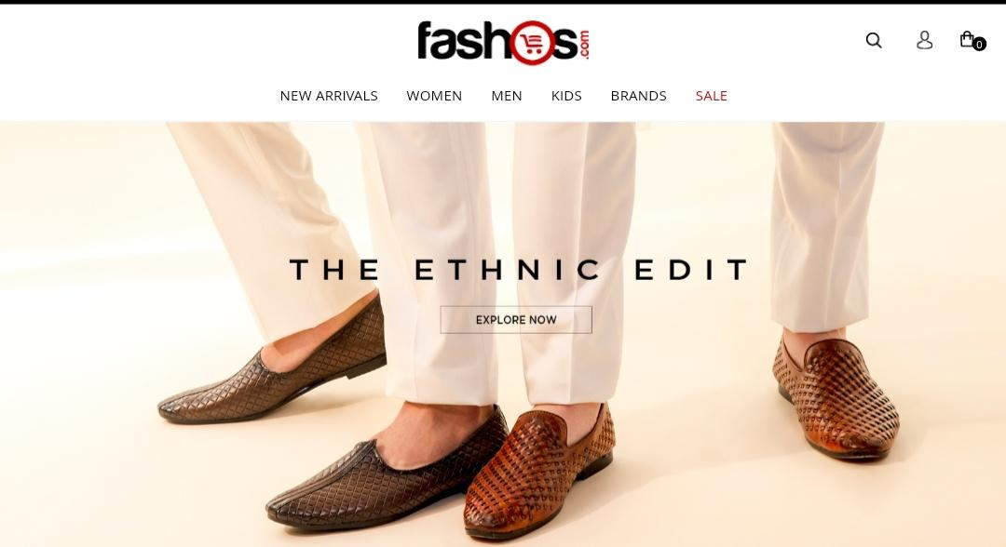

**OVERVIEW: it’s an e-commerce website for men’s shoes with all kind of shoes .**

1. **Home page:**

**:logo( wishlist,add to cart)**

**:icon**

**:search bar**

**:sliders with arrow(image)**

**:deals(image)**

**:featured(image)**

**:trending(image)**

**:footer- contact us ,helpline,brief description,about company,link to mobile app.**

1. **Registration form:**

**:E-mail**

**:D.O.B**

**:Shopping preference**

**:mobile number**

1. **Main Page:**

**:filters-(Brands,colour,discount range,price,occasion,pattern,rating,size,type,sort by.)**

**:image of the chosen product with details like-(Brand,Product name,Price,)**

**Product will appear from different angles ,zoom in,zoom out**

**:Product description - Brand,Product name,price,discount%,size chart,delivery options,product details, size fit,material,specification,ratings,coustmer reviews with image(if any).**

**:lower half of the page- related products\**

1. **PAYMENT PAGE -**

**:Address selection**

**:Payment method-(phone pe,google pay,cod,bhim upi,credit/debit card,net-banking,emi,paytm)**